Date 10/03/2024

Lesson 22

What Really Matters in This Section

<https://www.canva.com/design/DAEPH_Lq4Wk/wGpxJyUvCHfQT3jeXcs-Ww/view>

Lesson 23

What is Git repo?

You need to go inside each folder and say Git I want repo here. It allows you to have different histories.

Lesson 24

Our First Commands: Git Commands: Git init and Git Status

https://git-scm.com/docs/git-init

<https://git-scm.com/docs/git-status>

You only have to execute the command once git init. Will change the directory to initialize now.

This will show the hidden directory.

This is default folders. Hooks/info/objects/refs

The folder will be located in every git I initialize

Lesson 26

A common Early Git Mistake

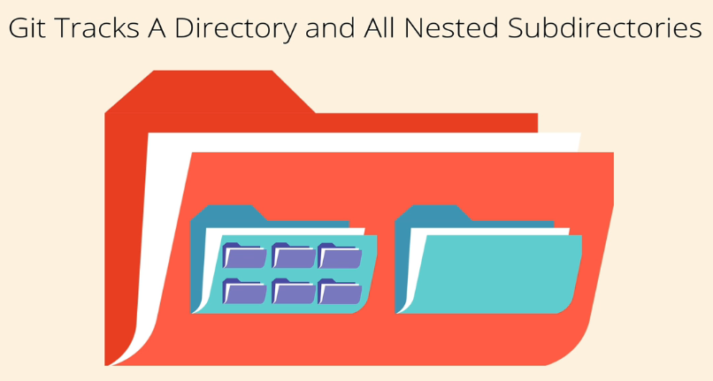

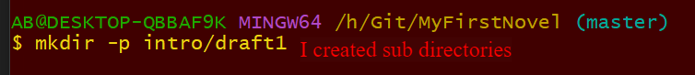

Git can track sub directories.

You can run git init inside an existing repository as things might go wrong.

Lesson 27

The Committing Workflow Overview

Lesson 28

Staging Changes With Git Add

Create character file

I want to make a commit.

That is the .git folder

Lesson 29

Finally, the Git Commit

If I run the commit now it will pop up the vim editor to enter message for the commit.

I committed in the video above.

11/03/2024

Lesson 30

The Git Log Command (And More Committing)

I only have 2 commits here.

Lesson 31

Committing Exercise

<https://plum-poppy-0ea.notion.site/Committing-Basics-Exercise-3dc1ef1873ce45e68cedd2265710d7d8>

